Ethan Elders

00099962

[eelders@my.athens.edu](mailto:eelders@my.athens.edu)

February 4, 2024

Assignment 2

1. Combined Assignment Operators
   1. x = x + 6;
      1. x += 6
   2. grade = grade – 10;
      1. grade -= 10;
   3. discount = discount \* (percent \* 2);
      1. discount \*= (percent\*2);
   4. loan = loan / (months – 2500);
      1. loan /= (months-2500);
   5. TotalGrades = TotalGrades / Students;
      1. TotalGrades /= Students;
   6. money = money % expense;
      1. money %= expense;
   7. number1 = number1 \* 6;
      1. number1 \*= 6;
   8. total = total – (number2 \* 4);
      1. total -= (number2\*4);
2. Gradebook
   1. 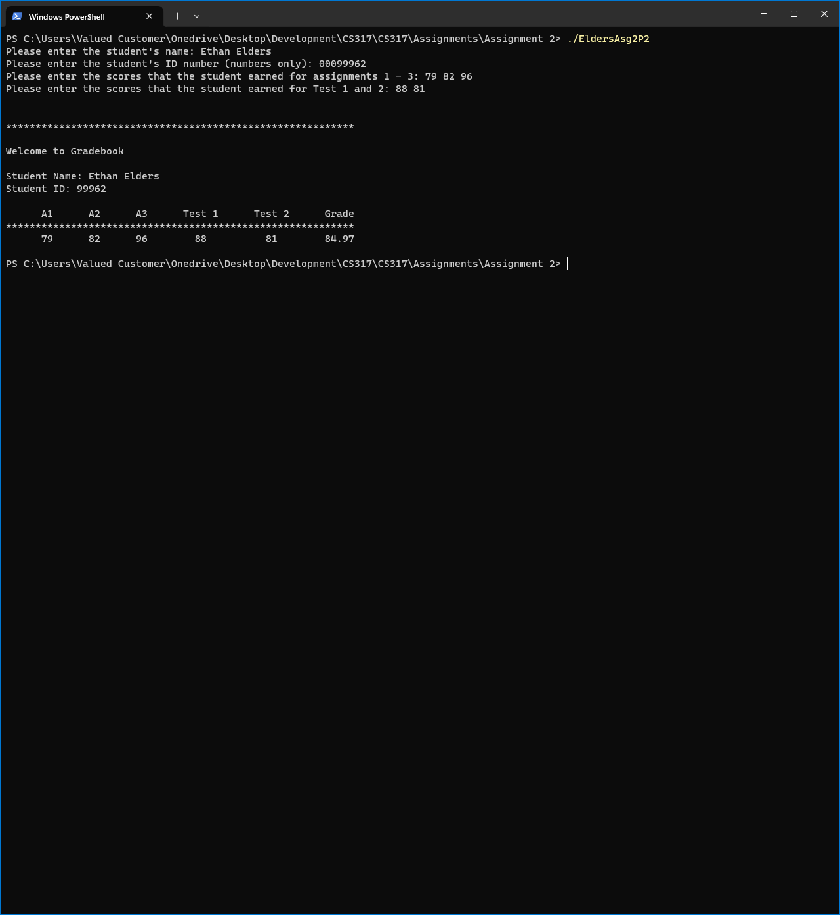
3. Pizza for dinner
   1. 
4. Word Game
   1. 
5. Fidget Orders
   1. 
6. Celsius to Fahrenheit
   1. 
7. Receipt Display
   1. 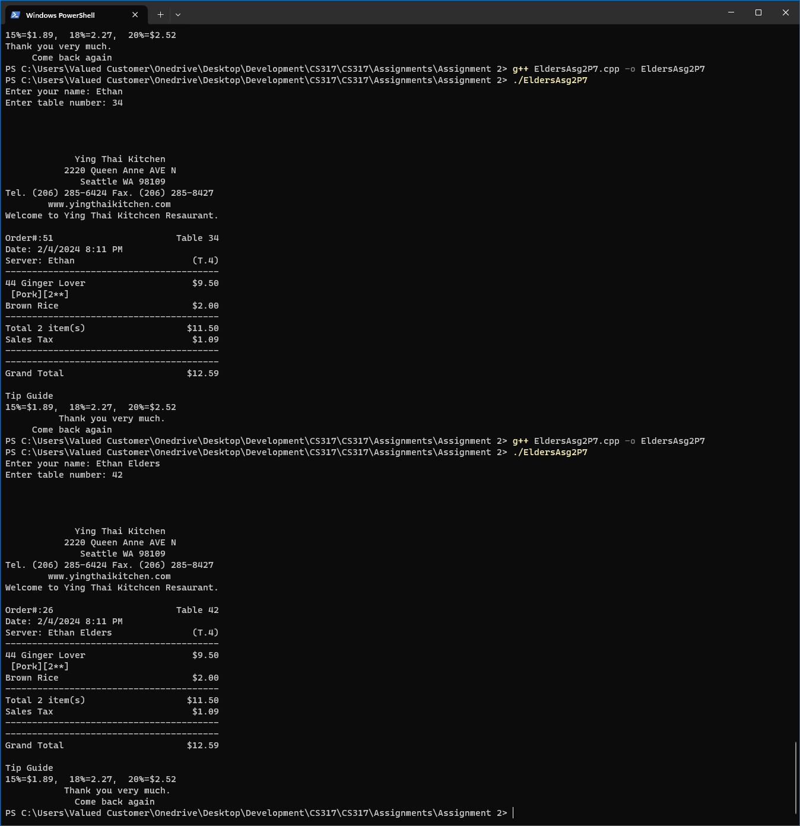
8. Powerlifting
   1. 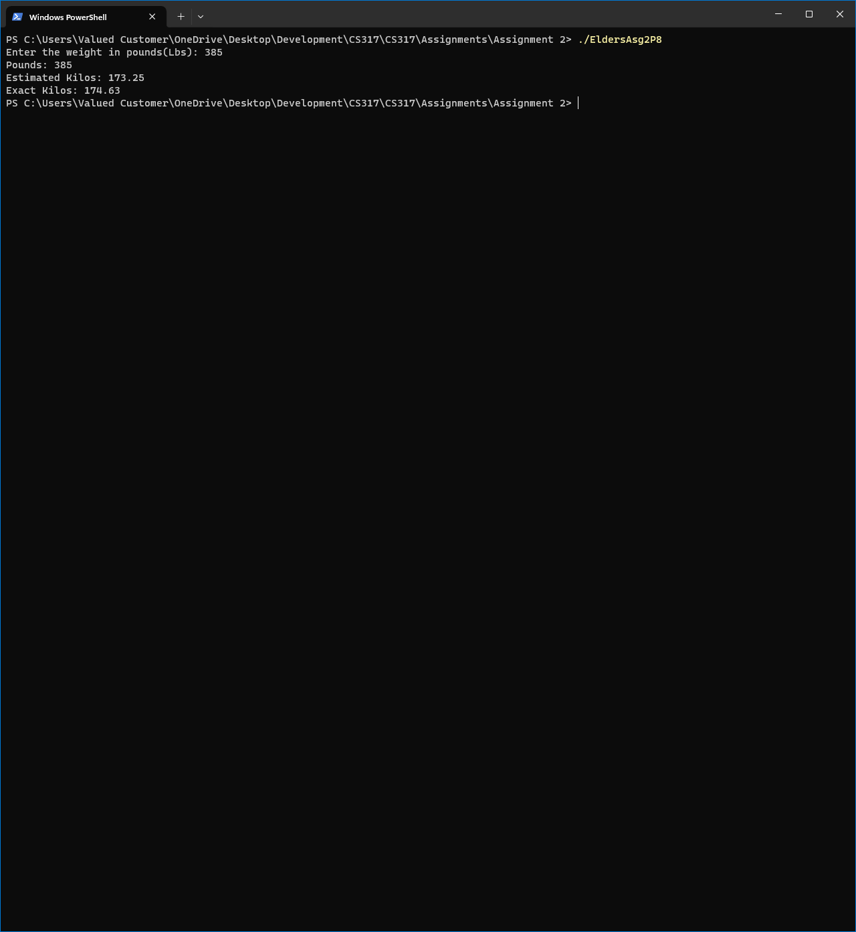
9. Go To Desserts
   1. 